Chapter 15, Solution 60.

Take the Laplace transform of each term of the integrodifferential equation.

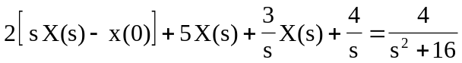

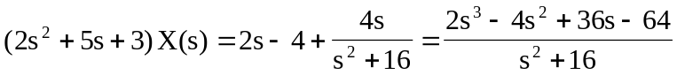

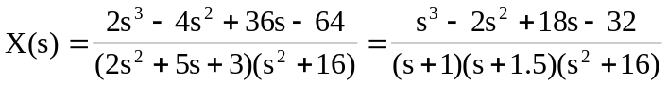

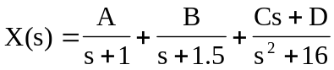

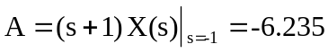
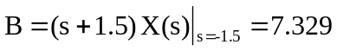

When 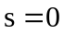,

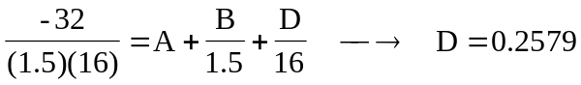

Equating coefficients of the 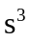 terms,

